CNNP- Skill 2

Name: P. Havishaa Reddy
Roll no: 2520030371
Section: 7

THREE-POINT CAPTURE – Analyze packet captures from three points in a network path to understand packet flow and identify performance differences.

STAGE 1 — Install tools

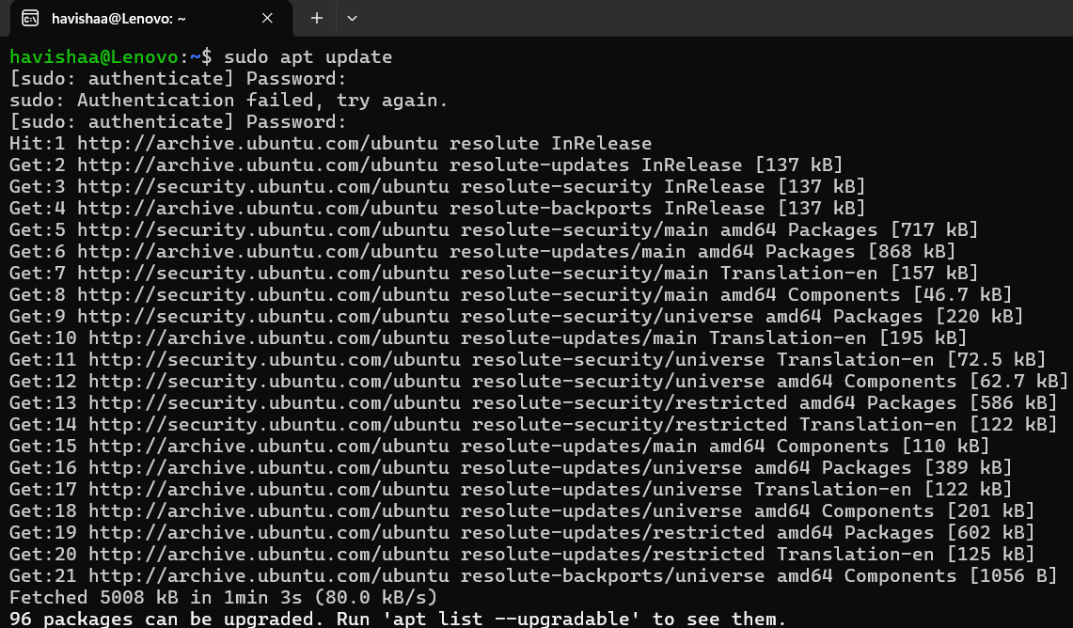

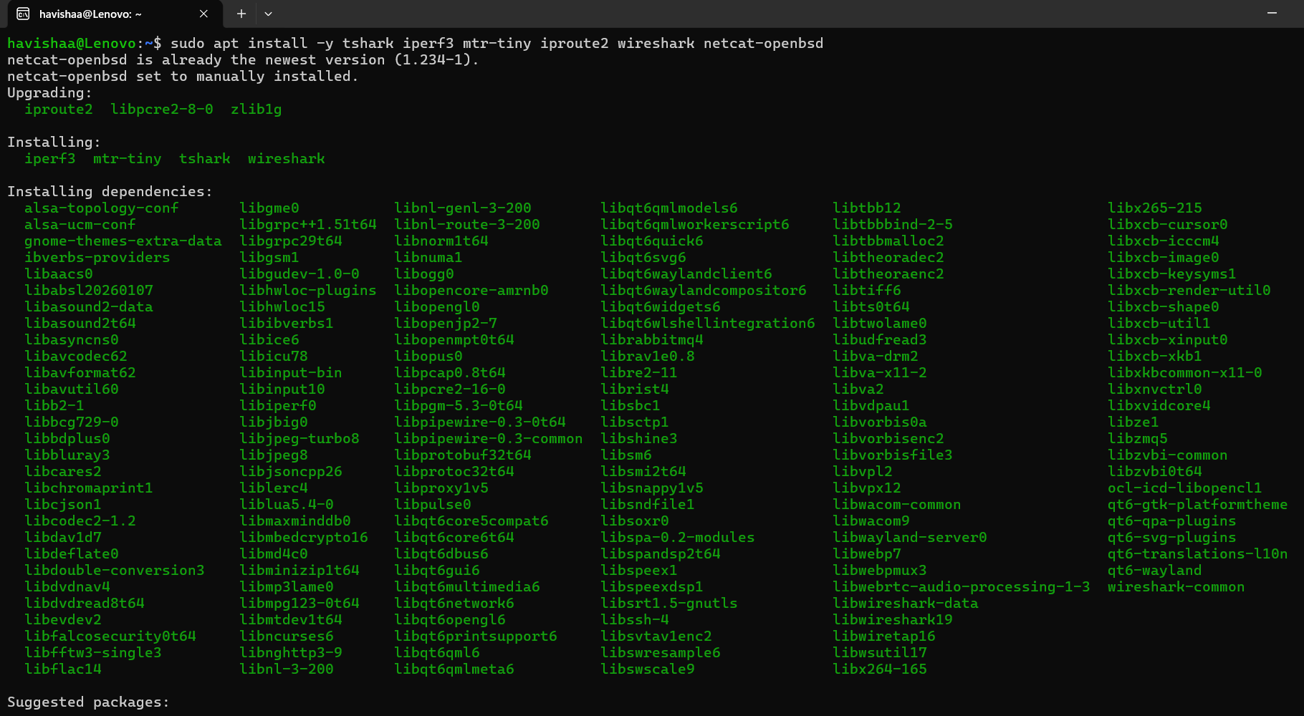

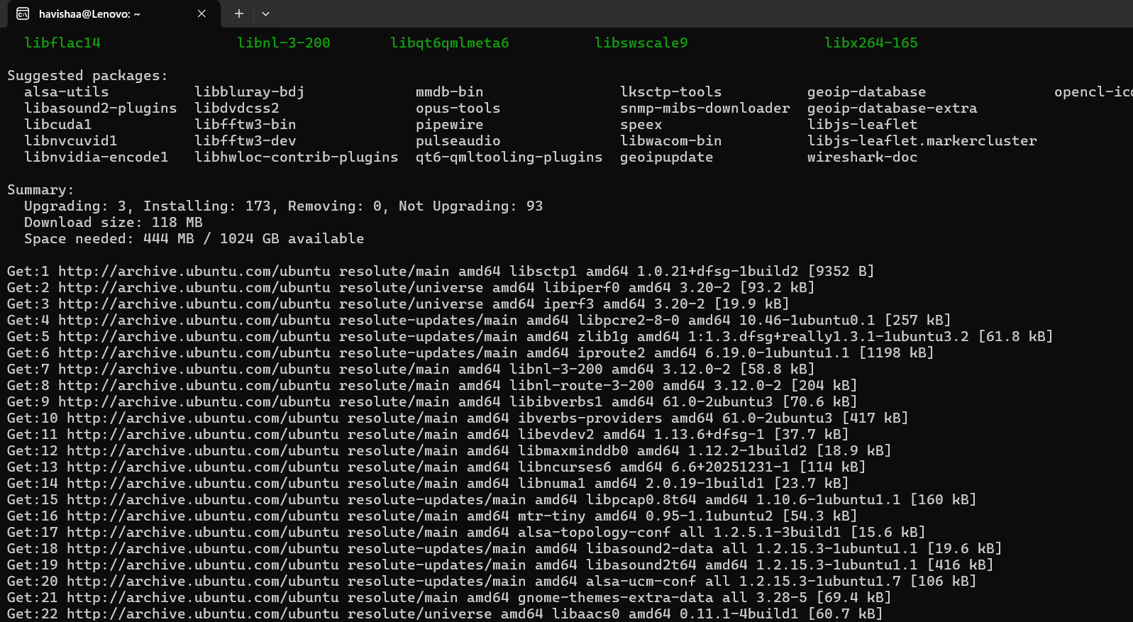

STAGE 2 — Build the network

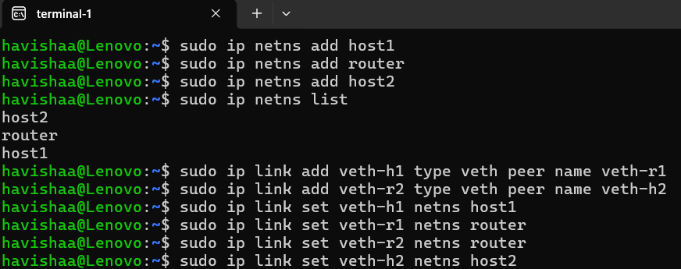

STAGE 3 — Configure IP addresses
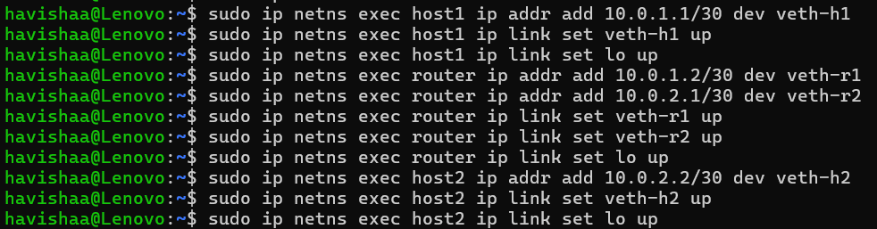

STAGE 4 — Enable routing
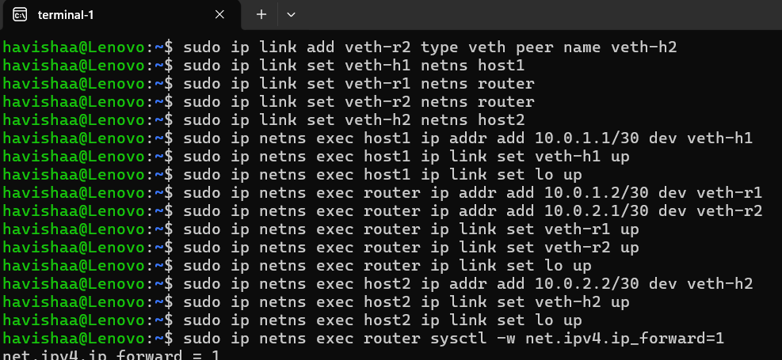

STAGE 5 — Test connectivity
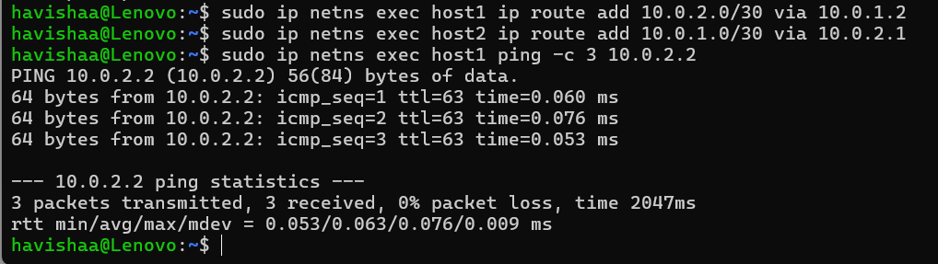

STAGE 6 — Add delay and loss & STAGE 7 — Open 4 terminals

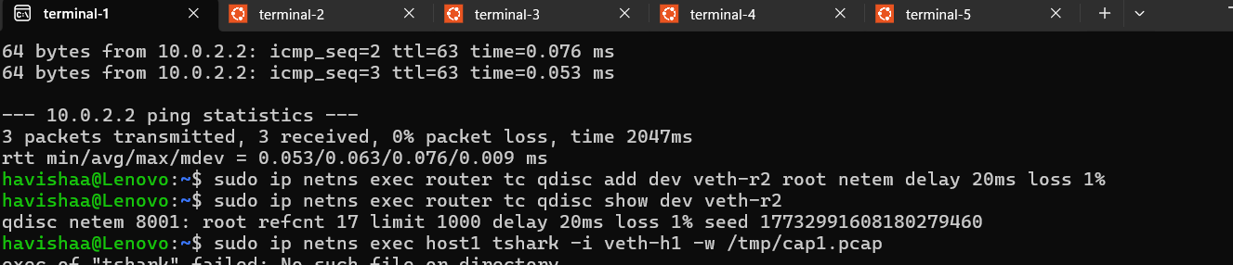

STAGE 8 — Start three captures simultaneously
&
STAGE 9 — Send real message from host1 to host2
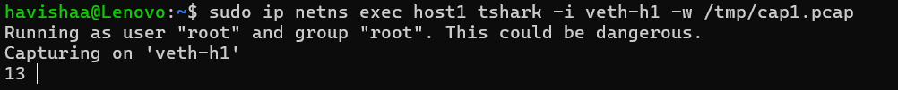

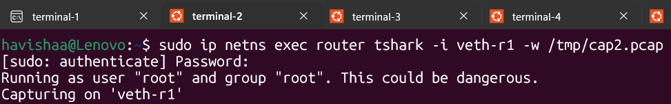
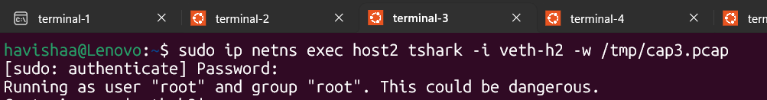
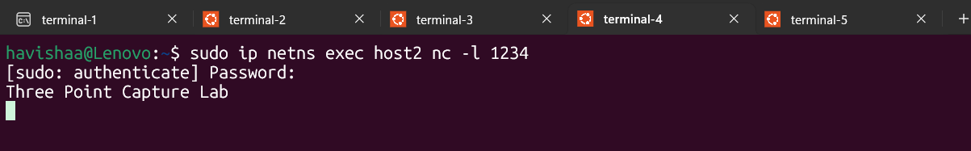
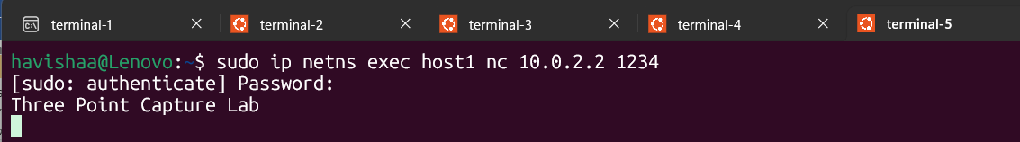

STAGE 10 — What you see in real time

Terminal 4:
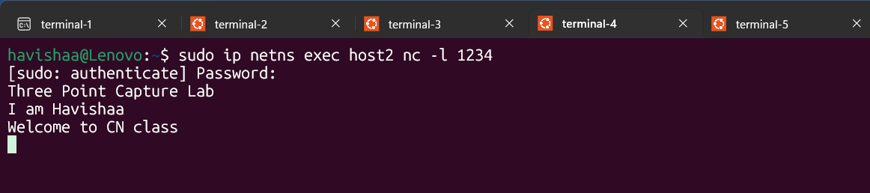

Terminal 5:
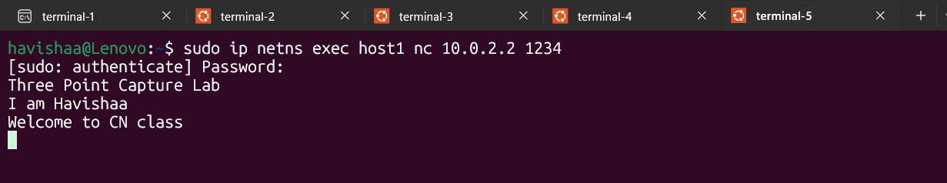

STAGE 12 — Fix permissions

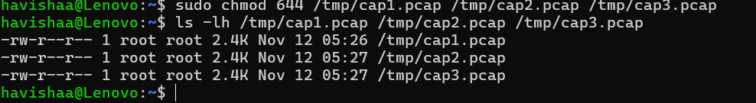

STAGE 13 — Check TTL
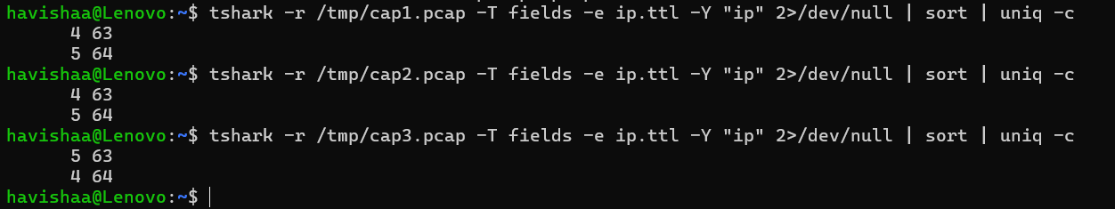

STAGE 14 — Read your actual message from the capture

The actual message was not displayed in plain text because the packet data was stored as raw TCP payload. Therefore, Tshark displayed the payload in hexadecimal format, which represents the transmitted message bytes captured in the network packets.

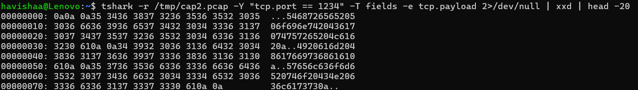

Stage 15 - Check Retransmissions

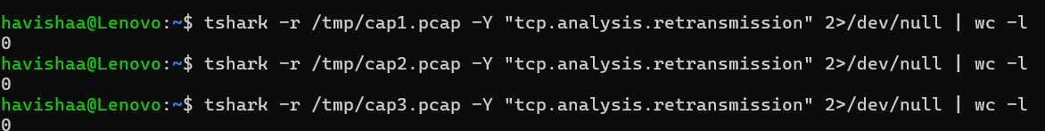

Stage 16 — Check RTT using mtr

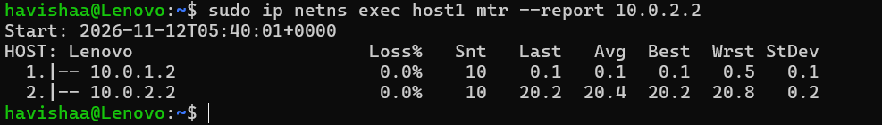

Stage 17 = Opening and analyzing the capture in Wireshark.

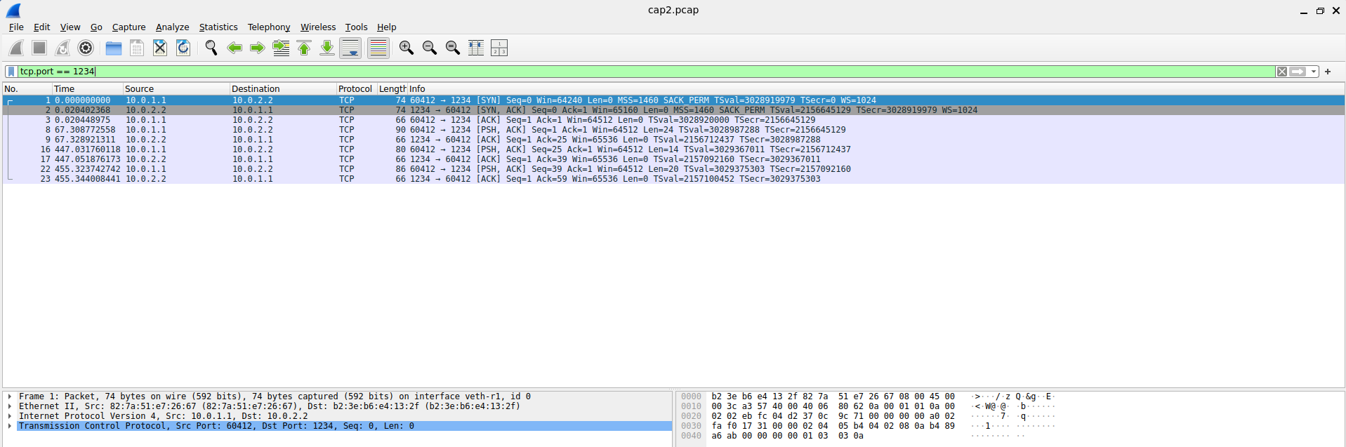

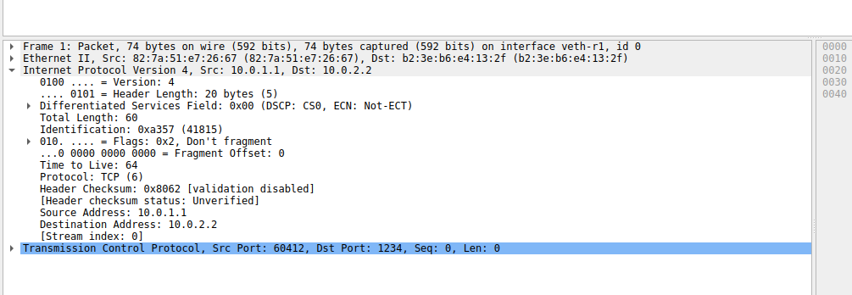

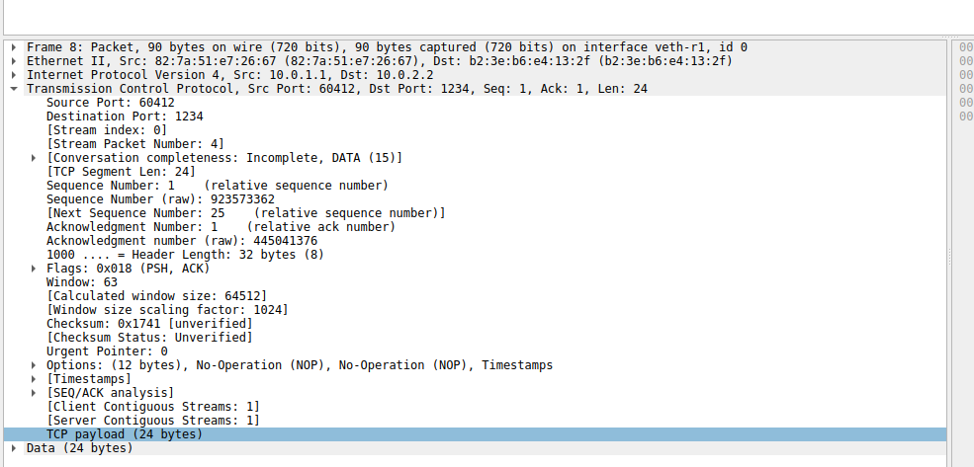

CLEAN UP:



